**30th Jan Python Assignment**

1. Display grade based on percentage.

**Code:**

grade=int(input("Enter your grades:"))

if(grade>100):

print("Please enter a valid percentage")

elif(grade>90):

print("A")

elif (grade>80 and grade<=90):

print("B")

elif(grade>60 and grade<=80):

print("C")

elif(grade>=0):

print("D")

else:

print("Please enter a valid percentage")

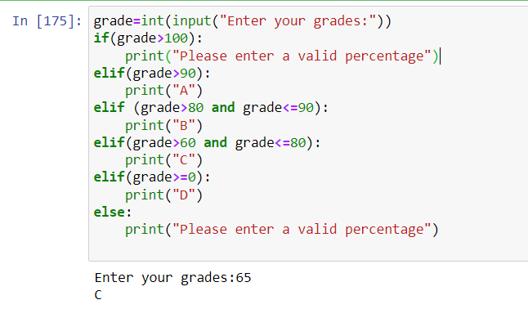

2. Display road tax based on price of your bike.

**Code:**

price=int(input("Enter your price of your bike:"))

if(price>100000):

print(f"Your road tax is {price*15/100}")

elif (price>50000 and price<=100000):

print(f"Your road tax is {price*10/100}")

elif(price>0 and price<=50000):

print(f"Your road tax is {price*5/100}")

else:

print("Please enter a proper salary")

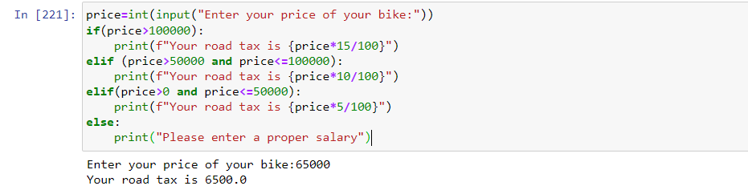

3.Display monuments based on the city.

**Code:**

city=input("Enter the city:")

City_To_Monuments={"Delhi":"Red Fort","Agra":"Taj Mahal","Jaipur":"Jal Mahal"}

if city.title() in City_To_Monuments:

print(f"The monument in the {city.title()} is {City_To_Monuments[city.title()]}")

else:

print("Please enter a valid city")

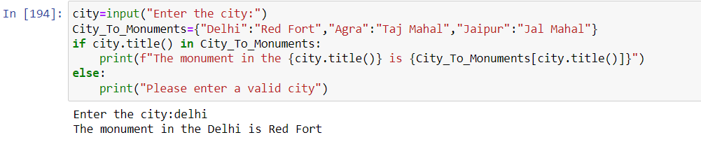

4. How many time the number can be divided by 3 before it reaches less than are equal to 10.

**Code:**

num=int(input("Enter a number:"))

count=0

while(num>10):

num//=3

count+=1

print(count)

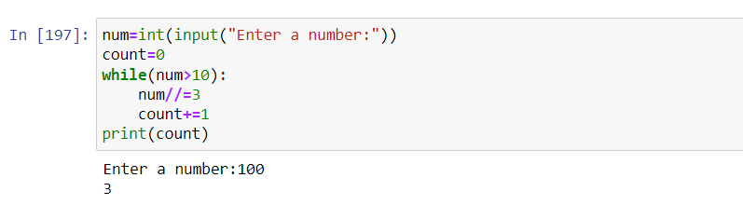

5. While loop should be used when the loop has to be exited if a specific value or group of values doesn’t match the condition.

Eg:

num=int(input("Enter a number:"))

count=0

while(num>10):

num//=3

count+=1

print(count)

6. Use Nested While loop to print 3 patterns.

**Code:**

num=int(input("Enter a size of the pattern needed:"))

print("\n Square \n")

j=0

while(j<num):

print("* "*num,end="\n")

j+=1

print("\n Rectange \n")

j=0

while(j<num//2):

print("* "*(num),end="\n")

j+=1

print("\n Triange\n ")

i=num-1

j=0

while(j<num):

print(" "*i+"*"*(2*j+1),end="\n")

j+=1

i-=1

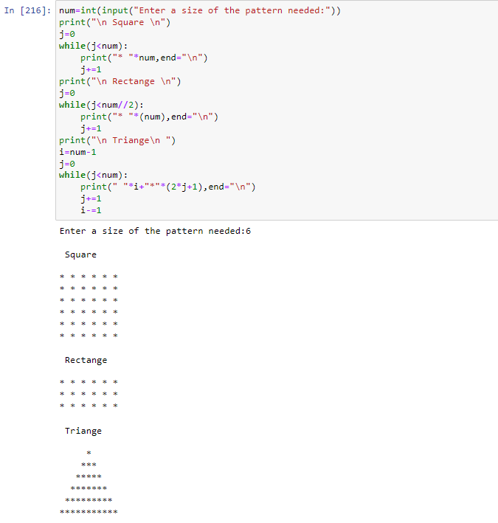

7. Reverse a While loop to display number from 10 to 1.

**Code:**

i=10

while(i>0):

print(i,end=" ")

i-=1

